# Converting Baseball Players' Height from Inches to Meters Using NumPy

Below is the image showing the exercise from DataCamp:

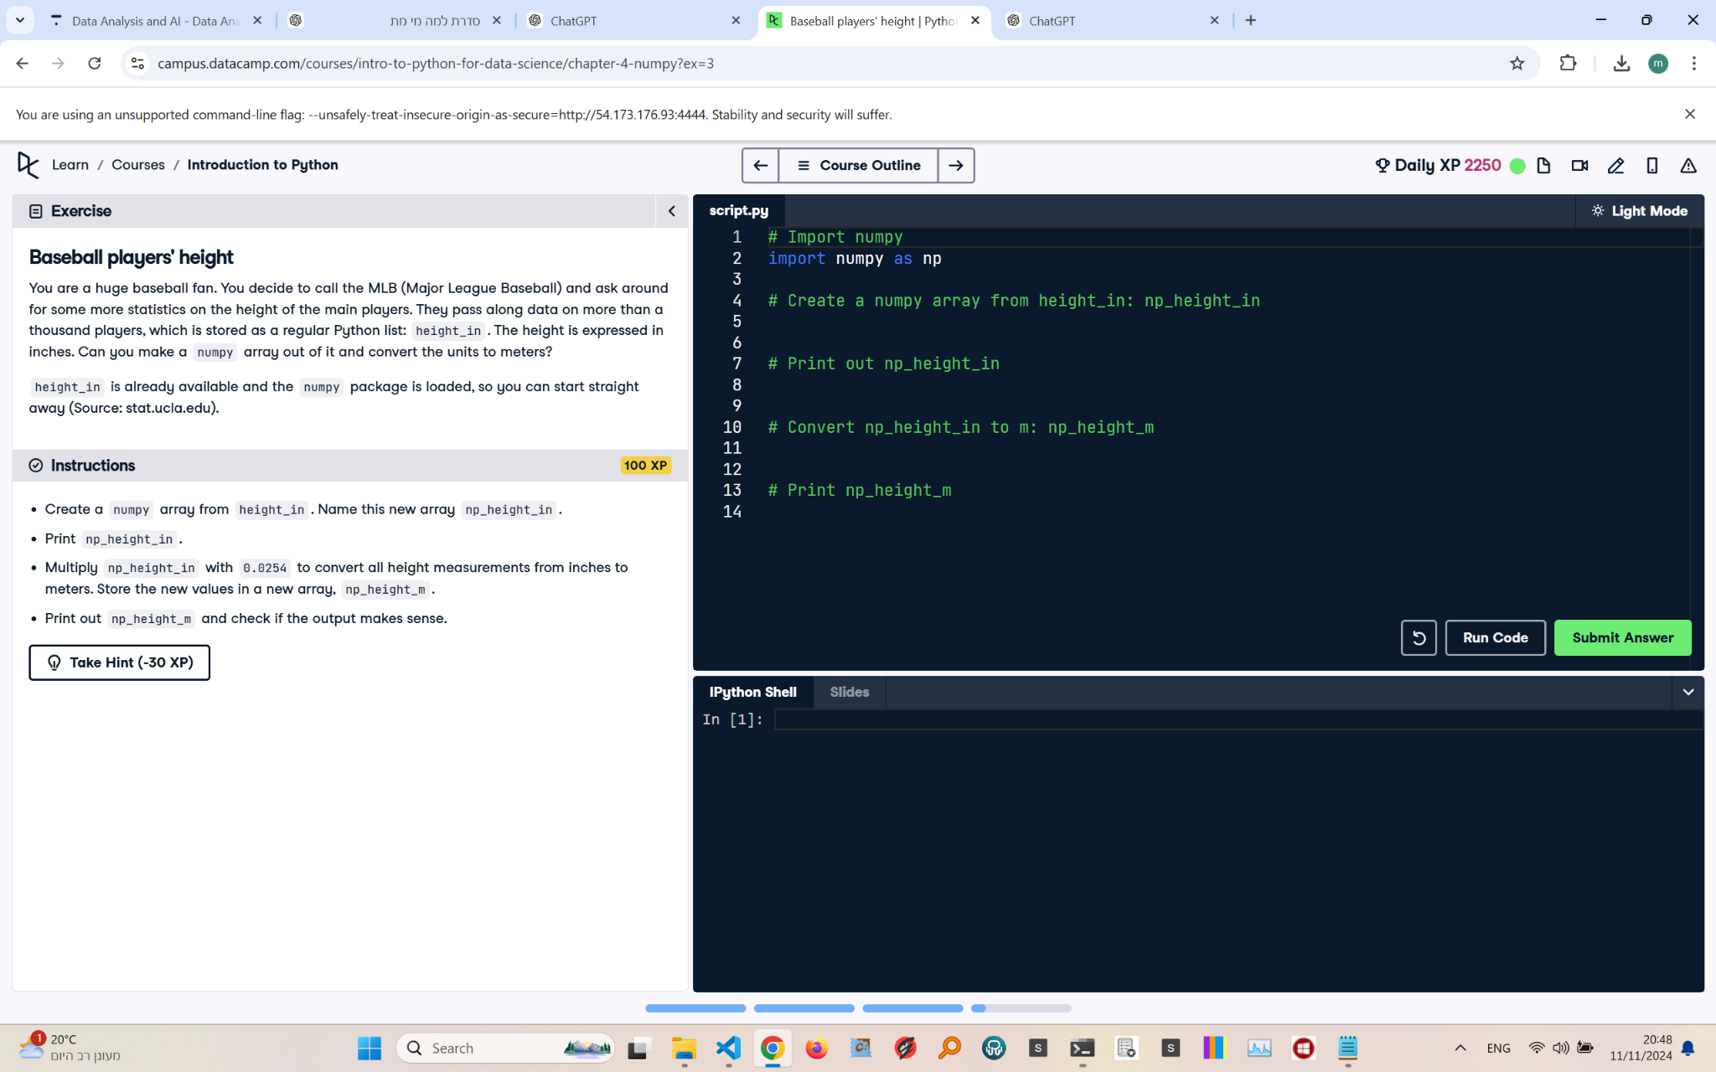

Exercise Explanation:

The exercise involves using the NumPy package to create an array from the given 'height_in' list. The goal is to convert the heights from inches to meters and print the resulting values.

Answer Code:

import numpy as np  
np_height_in = np.array(height_in)  
print(np_height_in)  
np_height_m = np_height_in * 0.0254  
print(np_height_m)

Explanation of the Code:

We first import NumPy as np and convert the 'height_in' list into a NumPy array named np_height_in. We then convert the values to meters by multiplying the array by 0.0254, the conversion factor from inches to meters. Finally, we print both arrays.